TOUSE: A Fair User Selection Mechanism Based on Dynamic Time Warping for MU-MIMO Networks

**Zhaoshu Tang,** **Zhenquan Qin, Ming Zhu**

**Jian Fang, Lei Wang, Honglian Ma**

School of Software,

Dalian University of Technology, China

[e-mail: tang.zhaoshu@mail.dlut.edu.cn]

*Corresponding author: Ming Zhu

***Abstract***

Multi-user Multiple-Input and Multiple-Output (MU-MIMO) has potential for prominently enhancing the capacity of wireless network by simultaneously transmitting to multiple users. User selection is an unavoidable problem which bottlenecks the gain of MU-MIMO to a great extent. Major state-of-the-art works are focusing on improving network throughput by using Channel State Information (CSI), however, the overhead of CSI feedback becomes unacceptable when the number of users is large. Some work does well in balancing tradeoff between complexity and achievable throughput but is lack of consideration of fairness. Current works universally ignore the rational utilizing of time resources, which may lead the improvements of network throughput to a standstill. In this paper, we propose TOUSE, a scalable and fair user selection scheme for MU-MIMO. The core design is dynamic-time- warping-based user selection mechanism for downlink MU-MIMO, which could make full use of concurrent transmitting time. TOUSE also presents a novel data-rate estimation method without any CSI feedback, providing supports for user selections. Simulation result shows that TOUSE significantly outperforms traditional contention-based user selection schemes in both throughput and fairness in an indoor condition.

**Keywords:** MU-MIMO, user selection, fairness, dynamic time warping

1. Introduction

**M**ulti-user Multiple Input Multiple Output (MU-MIMO) has already attracted a huge amount of attention because of the ability of better spatial reuse. The network capacity is dramatically enhanced by sending frames to multiple single-stream users concurrently. Prior to 802.11ac, traditional 802.11 protocol limits up to one user per transmission sent, which cannot fully utilize spatial resources supported by multiple antennas access point (AP). To solve this disadvantage, here comes the Multi-user transmission, a new technology within 802.11ac. By using MU-MIMO [1], AP is equipped with multiple antennas, and adaptable to transmissions among multiple users at one time. In possession with these abilities, MU-MIMO has the potential to change the way in which Wi-Fi networks are built and achieves improved capacity gains. Now, since 802.11ac has already been standardized, IEEE 802.11ac systems has been becoming widely deployed in real world.

Theoretically, the capacity of MU-MIMO downlink system gains increases linearly with the number of transmitting and receiving antennas. But in practice, the number of antennas is limited by several reasons, and the inter-user interference could not be ignored. These lead to a series of key problems. First, how an AP selects a beamforming group of users and transmits simultaneously. Second, how to determine the size of the beamforming group. Different beamforming group selection leads to various transmitting rates, then influences the overall network performances. Unwise selecting method may result in a huge waste of space-time at any single transmitted slot, in addition to the cause of the fairness and complexities. To make a better optimal selection, we should choose a metric like sum rate as a criterion to process the feedback information like Channel State Information (CSI) or Signal Noise Ratio (SNR), design an efficient scheduling scheme based on various data we obtained.

Substantial researches [2] have provided the solving methods to the user selection problem for MU-MIMO. Most solutions select the optimal beamforming group based on the full CSI feedback by all potential users, like semi-orthogonal user selection algorithm (SUS) [3] and minimum of the frobenius norm of the pseudo-inverse algorithm (MFNPI) [4]. CSI reflects the characteristics on the channel including fading distributions, average channel gains and spatial correlations, which all are the key factors for beamfroming group select. However, CSI is calculated by estimating the training sequence from AP, then users feed it back to the AP. Because of the long and compliacted process, reducing the CSI overhead seems to be a significance [5]. Although numerous optimization schemes of feedback have been proposed, like compression algorithms [6], the overhead of CSI feedback is still huge sometimes and severely affects the performance of network, since the overhead grows linearly with the number of users. Even worse, infrequent CSI feedback results in outdated, which may leads to the inter-user interference. It is convenient to select beamforming group within CSI, but intolerable for MU-MIMO system with unacceptable feedback overhead.

In fact, these challenges have motivated previous works to find better possible solutions for user selection. In [5], the author proposed a distributed contention mechanism that singles out the best user to feed back its CSI. Narendra [7] presented the pre-sounding user selection algorithm only using available pre-sounding information instead of posting channel sounding information, and solved the problem of feedback overhead to a certain extent. Other than theoretical contributions to MU-MIMO, Xiaofu [8] implements efficient algorithms in the practical 802.11ac systems with measurements considering both the throughput and user air time fairness.

In this paper, we propose *Time Optimal User Selection based on Effective SNR* (TOUSE), a scalable and fair user selection scheme for MU-MIMO networks to achieve higher throughput. To sum up, our main contributions are as follows:

1. We implement a low complexity feedback mechanism to obtain the available channel information and present a novel data-rate estimation method based on the information of effective SNR [9] without CSI feedback.
2. We design double constraint for user selection in order to maximize network throughput, and propose a novel dynamic-time-warping-based user selection algorithm to select beamforming group in a fair way.
3. TOUSE has abilities to adapt to different network channel qualities, no matter what the quality of channel. It is also suitable for dynamic network, since it selects users after channel sounding is completed and acquires real-time information (effective SNR feedback).
4. Finally we experimentally evaluate the performance of TOUSE. Result shows that, on average, the throughput gain of TOUSE is 1.5× over traditional random user selection scheme in 3-antennas AP scenarios and fairness performance is similar. Compared with PUMA scheme [7], TOUSE have similar performance in network throughput but better performance in user air time fairness.

The rest of this paper is organized as follows. In Section 2 we present background of user selection in MU-MIMO. Section 3 provides an overview of the components of TOUSE. Section 4 evaluates the performance of TOUSE with experimentations. Then we describe related works in Section 5 and Section 6 concludes the paper.

2. Related Work

Wireless standards like 802.11ac [10], LTE [11] have recently pushed toward the use of MU-MIMO for obtaining high-speed and high-throughput wireless communication. The work [12] presented a study to random access based on MAC mechanisms for MU-MIMO, and gives a survey and categorizes to the most relevant MU-MIMO MAC proposals. It also identified key requirements for designing efficient MU-MIMO MAC protocols including de/pre-coding [1] and scheduling schemes. The potential of MU-MIMO has been investigated both theoretically [13] and empirically [14], which studied pre-coding techniques, scheduling schemes and practical gain of MU-MIMO in various environments.

Substantial theoretical works [15] assumed that CSI is available and paid much attention on implementing low-complexity algorithms to approach the maximum throughput. Xie *et al*., [5] presented scalable and adaptive user selection which requires several rounds of CSI feedback instead of gathering from all users. However, in reality, the vulnerabilities of CSI [16] still exist due to its estimation methods, like time overhead. To avoid overwhelming the actual channel time spent on transmission, the schemes of user selection without CSI feedback was proposed. The authors of [17] design an orthogonality evaluation mechanism which enables each user using its own CSI to speculate. But it can only be applied to uplink MU-MIMO. In [7], it proposed a method of user selection prior to channel sounding and exploits theoretical properties of MU-MIMO system to estimate datarate. PUMA achieves better performance in throughput, however, it does not do well in the respect of fairness. In [18], it proposes an efficient method for combing multi-user MIMO (MU-MIMO) employing Tomlinson Harashima precoding with semiorthogonal user selection (SUS).

Some other works focus on the scheduling scheme of user selection [19]. Mostly [20] either iteratively select a user that minimizes the interference, reduces the complexity or maximizes the aggregate throughput. In [21], a novel search and updated strategy was proposed for user selection. It designed a knob to control tradeoff between aggregate capacity and computational complexity. The work [22] presents a low complexity scheduling scheme using block diagonalization with chordal distance.

In addition, some experimental studies emerged, like [23]. Authors realizes netMIMO downlink transmission for large-scale wireless network. By organizing a network into clusters, it could manage interference with a decentralized channel-access algorithm, but environment is limited in static network since time-averaged CSI is used as input. In [24], Shen *et al*., introduced TurboRate, client annotates its packets with single SNR and direction at the AP to obtain the optimal bit rate and could transmit concurrently. Now there are more conditions are considered, like mobility [25] or channel control [26]. The exciting thing is that the team of Xinyu Zhang [27] has optimized MU-MIMO performance in 802.11ac commodity devices. In [8], it develop an efficient graph matching algorithm based on graph theory principles and evaluate in terms of 802.11ac systems.

So far, there are three key points in MU-MIMO MAC protocol design: throughput, complexity and fairness [28]. But most researches only consider two or one of these points. TOUSE is designed a novel metric without CSI feedback benefiting from [29], and presents a fair user selection mechanism based on overhead time matches.

3. Background and Challenges

3.1 MU-MIMO System Model

In a downlink MU-MIMO system, consider a single-cell MIMO with a single base station serving users. The base station is equipped with antennas and the client with one or more receive antennas. We assume that AP sends frames to a set of selected single antenna users called beamforming group at the same time, which satisfies , . Due to the bad effect of multi-user interference at the client side, it is essential for AP to precode outgoing signals to minimize the bad effect of interference among simultaneous streams. Owing to its low complexity, AP applies Zero-forcing beamforming(ZFBF) [5]. In ZFBF, user streams are separated by different beamforming directions. Let denotes the data symbol sending to user , be the beamforming weight vector, and present the transmit power. Assume is the channel state vector between transmission antennas and receiver . Define , , the transmitted signal . Then, let denotes the noise level of user , and the received signal vector is:

(1)

To eliminate the interference from other beamforming frame streams, ZFBF should satisfy the zero-interference condition: for all receivers , . So that receiver only gets its symbol . Let the channel state matrix and the beamforming weight matrix . One optimal choice of **W** that satisfies zero-interference condition is the pseudo-inverse of **H**:

. (2)

Thus, another problem that needs to be considerd is power allocation. For simplicity, we adopted ZFBF-EP [14] scheme where the transmitter allocates equal power to its users, and ignore the problem of power allocation approaches with ZFBF.

3.2 Impact of User Selection Mechanism

From above section, the performance of ZFBF is highly dependent on the channel vectors from transmitter to receiver. When the channel vectors of different receivers are uncorrelated with each other, it is most likely to improve the network capacity gains. It has been proved by the experimental [14][30] for indoor wireless network. The network spatial multiplexing gain of ZFBF can be increased by a high number of transmitter antennas, wherever the location of receivers in indoor environment.

Selecting beamforming group is one of the key issues which are related to the performance of MU-MIMO system. From **Eq. (1)**, the SNR of each receivers depends on its group member. If one receiver's channel vector is orthogonal to another, it will cause limited interference when transmitting together. The research [14] also proved that the SNR or the size of beamforming group has great influence to the performance of ZFBF. The optimal size of beamforming group depends on the link state of the members. The state of queue and other information should be taken into account as well.

3.3 Challenges in User Selection

User selection is a complicated process. Although optimal transmission beamforming group can improve the network capacity, high computational overhead is unacceptable. Before each downlink transmit, the AP need obtaining the CSI from the users' feedback. During the feedback process, AP sends a training sequence to the target users, users calculate the CSI by the training sequence and send the feedback of CSI to AP in order sequence. Due to this mechanism, overhead by CSI feedback also increased with number of users. In MU-MIMO system and 80MHz channel, the size of CSI feedback matrix about 500bytes. Researches [5] present that even with users, the total time overhead of CSI feedback in existing schemes can be comparable to or even competitive with that of actual data transmission.

There are a number of factors which a user selection mechanism should be considered. First, how to determine the size of beamforming group. In a transmission time slot, AP beamforming to send frame to a set of user , which the size of set satisfy . In [14], it proved that maybe have a better network performance than the case of . The authors of [7] proposed an aggregate throughput to select the combination mode. Second is the complexity reduction. Instead of exhaustive search over all possible combinations, most researches adopt the local optimal methods to solve this problem, which performs inefficiently. It is hard to achieve both low complexity and high performance. So the tradeoff between performance and complexity is essential [21]. Another solution is to reduce the feedback overhead, which is not the way to the underlying problem. The last challenge is how to realize fairness. A simple way to improve the network throughput is just selecting the users which have a high link quality. But it might not be fair for all users. Sometimes, it will cause starvation.

4. TOUSE Design

4.1 Design Overview

The design inherits the advantages of throughput fairness and low complexity in user selection, it also improves the network capacity gain. TOUSE presents a new preference metric which aims to make full use of time resource and guarantees fairness. Besides, instead of requiring CSI feedback, TOUSE provides a mechanism in which AP just obtained effective SNR from users to make decision. This mechanism has limited time overhead compared to the CSI feedback.

Before giving the details of TOUSE, there are some available pre-sounding information to introduce. In MU-MIMO system, AP owns the information of system state and queue state before channel sounding or communication. For each transmission, AP knows the hardware configurations, like available number of transmission antennas , the number of clients' receiving antennas. AP is also aware of the queue state information for each users, like each user's backlog or queue size. The amount of available data directly affects the data transmission time in each transmission, which is used for user selection. By leveraging this information, we design a performance metric to select optimal beamforming group. The TOUSE works as follows:

**1)** First, the AP announces its intention for MU-MIMO downlink transmission through the Null Data Packet Announcement (NDPA) frame and Null Data Packet (NDP), and it is the time to start the MU-MIMO sounding process for users. AP randomly selects a first user into the optimal beamforming group, which can achieve channel access fairness.

**2)** Then, each user estimates its own CSI independently based on the NDP frame. AP obtains the effective SNR feedback which is calculated by each client based on the CSI. This is the first round of TOUSE user selection.

**3)** In subsequent round, AP estimates the potential datarate for each competitors based on the effective SNR and current beamforming group. Then it calculates time of data transmission for each users combined with the pre-sounding information, and gets global time of transmission slot based on selected users and candidate users.

**4)** Given transmission time of each data transmission and information of selected users. According to the constraint condition (described in subsection 4.4), the AP selects the best candidate which can optimize total network throughput for this transmission slot.

**5)** The one who satisfies the optimal constraint, indicating the ability of the transmission among the members of beamforming group. Then the AP adds it to the beamforming group.

**6)** Repeat step (3)-(5) until the size of beamforming group reaches the maximum transmission numbers , or there exists no any best choice left. Finally, AP would terminate the user selection process.

Next, we are going to present TOUSE in details for better understanding.

4.2 Effective SNR

In order to accurately predict the packet delivery rate, a key point is using effective SNR (ESNR) [9]. It is a simple, easy-to-deploy, broadly useful, and rather accurate method. Effective SNR consider the factors of transmit power and antennas, which makes packet delivery predicted for 802.11n MIMO rates more effective. During the process, CSI is the input, which can provides the SNR values for each subcarrier. It is contains more information than RSSI, and provides the opportunity to of designing an accurate evaluate model.

In OFDM, decoding is applied across the demodulated bits of subcarriers, and frequency-selective fading made some weak subcarriers will be much more likely to have errors than other stronger. The effective SNR calculation is not just the average subcarrier SNR. Instead, it is biased towards the weaker subcarrier SNRs because the subcarriers cause most of the errors, and CSI gives the SNR values to use for each subcarrier. From 802.11 standard, it formulas summarized relate SNR to bit-error rate (BER) for the modulations. The defined of effective SNR would give the same error performance on a narrowband channel. The effective SNR is calculated by averaging the subcarrier BERs and finding the corresponding SNR, which is more effective for packet delivery rate predictable. Generally, the value of effective SNR is unlike the RSSI. The formulas are shown as follows:

; (3)

. (4)

presents the inverse mapping, from to and is the number of subcarriers. denotes the average across subcarriers, is the SNR values of each subcarrier.

4.3 MU-MIMO User Datarate Estimate

In TOUSE, the key is to predict the per-user packet delivery rate. During the process ESNR evaluation is essential for each transmission. Then the AP obtains the data rate for each user from the ESNR by using MCS (modulation and coding set) table. However, There is still a problem when it comes to AP transmissions among multi-receivers at the same time resulting in the inevitable of the inter user interference. As a result it will influence the total throughput of network.

**1)** Traditional Rate Estimation: One of the classical approach to calculate the aggregate capacity is using channel state matrix. The sum rate () [5] is achieved by following scheme:

 (5)

subject to .

This method is accurate but quite complex. It requires channel state matrix as input which is difficult to obtain. Given the significant overhead of CSI feedback, the AP needs more reasonable utilizations of this information to maximize the network performance. This leads to the system more complicated and hard to implement, which is opposite to what we originated.

**2)** ESNR based Rate Estimation: TOUSE's rate estimation method is based on theoretical MU-MIMO system scaling. In order to make it facilitate and precise, AP obtain the ESNR which is calculated by users, and estimates the data delivery rate by MCS-SNR table. Besides, qualifying the influence of inter-user interference when AP transmits to multi-users is also essential. As mentioned before, in ZF model, user only receives its desired symbol owing to the composite effects of precoding and channel distortion. The main features of ZF is complete interference cancellation with full CSI, but it will amplify the noise [12].

Many works [31] provide the analysis to network capacity performance influenced by ZF-precoded system. But most of methods are not suitable for our purposes because too much information is required. By the ZF criterion, there is residual interference due to the imperfect CSI-based beamformers. The SINR for selected user is (proposed in [29])

 (6)

and the corresponding sum rate is . Where presents the precoding unit-norm beamforming vector for user is chosen in the direction of the projection of on the nullspace of ,.

**Eq. (6)** presents SINR variation for each users, but there is the same problem of using information of CSI as input. As **Eq. (6)** shows that the interference caused by other receivers in beamforming group is related to per-receiver SNR. Besides, the system state information also has great influence on the SINR, like transmission antennas number and the size of current transmission users group . It is also necessary to note that this paper focuses on the users equipped with a single antenna. In [32] and [29], it proved that in order to achieve the full multiplexing gain. The transmitters must have perfect channel knowledge in order to choose the zero-forcing beamforming vectors. However due to the imperfection in this knowledge, there will be some multi-user interference, which leads to performance degradation inevitably. Therefore, we proposed a suitable per-receiver SINR estimation method as following.

. (7)

Where is the number of transmitting antennas, presents the degree of freedom of MU-MIMO system. denotes the size of beamforming group, which leads an exponential increase in the multi-user interference. This estimation method was actually inspired by follow result, it is shown that the sum rate of ZF beamforming with CSI but without user selection ( users are randomly selected) is low bounded by:

 (8)

Where is the perfect CSI rate, which means without multi-user interference. present the number of feedback bit, which indicates the CSI accuracy in ZF beamforming.

In TOUSE, we assume that each transmission antenna has a same transmitting power . As the size of beamforming group increase, the interference increases exponentially by concurrent transmit user. From **Eq. (7)**, the value of per-receiver SINR is inherently less precise than **Eq. (5)**. But it can provide a sufficiently accurate result for TOUSE user selection process, and easy to implement. Then the transmission data rate for user is calculated from the MCS-Rate (**Table 1**) by the minimum SINR required.

**3)** TOUSE Rate Estimation Analyses: In **Eq. (7)**, the TOUSE's SINR estimation method only requires the system hardware configurations, , number of users and the ESNR calculated by each user. This estimation scheme can accommodate with the network dynamically by using ESNR, and avoid CSI feedback overhead at the same time. presents the multiplexing gain of inter-user interference, and it will increase linearly with the increase of transmission power. Thus, the SINR of each user is related to in MU-MIMO system.

During the rate estimation process, TOUSE first measures the channel state information, and calculates the ESNR by each receivers. Then the each user's SINR is calculated based on the size of beamforming group. Finally the data delivery rate (for packet reception rate) is obtained by using the MCS-SNR table [33] provided by the standard (as shown in **Table 1**).

**Table 1**. Minimum SNR required

|  |  |  |
| --- | --- | --- |
| MCS | Rate (Mbps) | SNR (dB) |
| 0  1  2  3  4  5  6  7 | 6.5  13.0  19.5  26.0  39.0  52.0  58.5  65.0 | 1.1  4.1  6.7  9.6  12.8  17.2  18.4  19.7 |

4.4 User Selection Mechanism

In this section, we present the user selection mechanism to maximize the aggregate throughput of network, and ensure the fairness of channel access for each users. In this subsection, the key point is the two types of limiting condition for user selection mechanism.

Previous sections have given the data rate estimation method. In order to calculate the data transmission time for a transport connection, the key point is total delivery data and network overhead (such as channel sounding and ESNR feedback overhead). These pre-sounding information can be obtained by AP queue state or network measurement. So the total throughput for each transmission slot can be calculated, which is the performance metric for user selection mechanism. The formula is as follows, denotes the total transmission data at a time slot, is the maximum transmit time of all downlink transmission and is the network overhead.

. (9)

Here introduce some definitions, First, denotes the th round selected beamforming group and is the size of , , denotes a user which is candidate for round select from the unselected users, but still waiting for checking by mechanism. presents the transmission time requirement that AP transmits the queue data to user , which means candidate user transmit with concurrent beamforming group . is the total queue data delivery to user in this transmit slot, is the data delivery rate estimate by rate estimation method which is present at above subsection.

In order to achieve the two design goals: throughput increment and fairness guarantee. We design a similarity matching algorithm for optimal user group selection based on dynamic time warping [34]. This subsection give double constraint for user selection mechanism. Here is the first constraint: *throughput constraint*, to maximum the aggregate throughput.

 (10)

Where presents the one with maximum data transmission time in concurrent selected beamforming group. , is the ratio between the data-rata of user at the mode of and . The size of beamforming group has a great impact on the transmitting rate of each user, this constraint make sure increase the size of beamforming group not at the expense of throughput. For example, here is a user in beamforming group which the size is , the data delivery rate is , but delivery rate equals in the mode of , then . **Eq. (10)** is a throughput constraint for network performance, which enables to judge the benefits of user in this transmit time slot. Then this user will judge whether to put it into the beamforming group or just throw it away. As mentioned before, increasing the size of beamforming group may lead to inter-user interference. This constraint quantize the relation between benefit and inter-user interference. Therefore the total network throughput performance should be considered when putting candidate user into beamforming group.

The second constraint aims to make full utilization of space-time resource, *time constraint*, as following.

. (11)

denotes the size of beamforming group which is received transmit date from AP concurrently. This restriction allows our user selection mechanism to find an optimal match with concurrent selected beamforming group. This constraint obtained based on the principle that do not increase the transmission time waste. For example, in a transmit slot of 22 MU-MIMO system, AP transmits to *user1* and *user2*, while the transmission time of *user1* is 1s and *user2* is 100s. In this case, compared with *user2*, the transmission time of *user1* is too short, which is not a best choice to bind them together for total network. If *user1* belonging to the beamforming group, it’s a bad choice to put *user2* into beamforming group, due to it will make *user1* waste 99s and maybe there will be a best partner for *user2* in next transmission time slot. But if *user2* belonging to the beamforming group, it’s ok for *user1* transmit together with *user2*. This time if only transmit *user2* alone, time waste is 100s, due to transmission resource waste. But if put *user1* into beamforming group, it only waste 99s, which is not bad for system.

Based on the idea of dynamic time warping, the algorithm was designed to find an optimal beamforming group which can improved the network throughput. The AP is selected by the correlation of transmission time between candidate user and current beamforming group. In the process of user selection, AP selects the first user into beamforming group at random, then the other member of beamforming group is selected by correlation with the set of selected users. This process will go through the total unselected users until no one is detected, which indicates that current beamforming group is an optimal solution at a transmitting slot.

TOUSE user selection mechanism is based on data transmission time, which leads the contention is fair in term of SNR of users. Next section will present the fairness performance of our mechanism. **Eq. (9)** shows that the network overhead limits the performance of a MU-MIMO transmission. Along with the increasing of beamforming group size, the amount of total transmit data grows. The larger amount of network overhead is created meanwhile. So it is an important issue to get the trade off between aggregate data and network overhead.

4.5 TOUSE Algorithm

|  |
| --- |
| **Algorithm 1** TOUSE User Selection |
| **Input:**  The set of single antenna users, ;  The number of transmit antennas and transmit power, and ;  **Output:**  The set of solution receivers, ;  The size of solution group, ;  **Begin:**  **while** and **do**  **if**  **then**  Selecting a solution at randomly from ;  , ;  **else repeat**  Selecting a receiver , with closest transmission time to ;  Judging by two constraint: **Eq. (10), Eq. (11)**;  **if** satisfies the two constraint **then**  , ;  Break;  **end if**  **until** Get the solution or none of optimal solution meets the condition;  **end if**  **if** **then**  None of receiver matches ;  Break, terminate the process of user selection;  **end if**  **end while** |

In order to seek an optimal combination to improve the network throughput, TOUSE applies two constraints which have been mentioned. Given the set of candidate receivers which is the total candidate users in one transmission slot. TOUSE selects the best combination as beamforming group for AP to simultaneous downlink transmissions. Here is the TOUSE user selection algorithm.

The **algorithm (1)** shows the user selection process of TOUSE's. The input of this algorithm is a candidate set of users, and the output is the beamforming group , . In the first round, AP selects a solution randomly from candidate set, in order to meets the requirements of competition fairness. Then the double constraint process is repeated until a receiver matching the existing solution group is selected, or none of optimal solutions exists in candidate receivers, as shown in the **Algorithm (1)**. It select a user from candidate group, the transmission time of this user is most similar with the time of concurrent beamforming group, and judge whether this user is satisfied double constraint. During the process of searching solution, each selected user is the best one while group with the concurrent solution. This searching method can reduce the complexity of TOUSE, and the result was acquired rapidly and exactly.

5. Performance Evaluation

In this section, we further perform simulations to evaluate the performance of TOUSE in indoor environment. The simulations aim to answer the following questions:

1. How much capacity gain can TOUSE achieve in comparison with existing schemes?
2. How does TOUSE perform in terms of fairness compared with existing schemes?
3. How much the number of transmit antennas impact on TOUSE?
4. Does TOUSE scale?
5. Could TOUSE work in different channel quality region?

For the performance comparison, we implemented three state-of-the-art user selection schemes: (1) Pre-sounding User and Mode selection Algorithm (PUMA) [7]. PUMA allows MU-MIMO system to efficiently transmit multiple streams by using pre-sounding information. It estimates the throughput of all potential user group combinations. (2) Mixed PUMA algorithm (PUMA-MIX). PUMA employed exhaustively searching method to find the optimal user group. We replaced it with iteration method using for comparison in simulations. (3) Random User Selection (RUS), essentially the default standard of 802.11 ac, which randomly selects users with equal probability.

In our simulation, we randomly distribute the users around the AP. All MU-MIMO transmissions run on a 2.4GHz channel unused and non-overlapping with ambient wireless devices. Other PHY parameters follow the IEEE 802.11ac default (e.g., 20MHz bandwidth and 64 subcarriers). The channels are generated according to the Rayleigh fading channel model, and the transmit power of each antenna is . The AP is allowed up to 4 transmit antennas and it serves a group of 10 single antenna receivers (, ), due to the MU-MIMO transmission are limited to four clients. The detailed setting will be specified in each simulation.

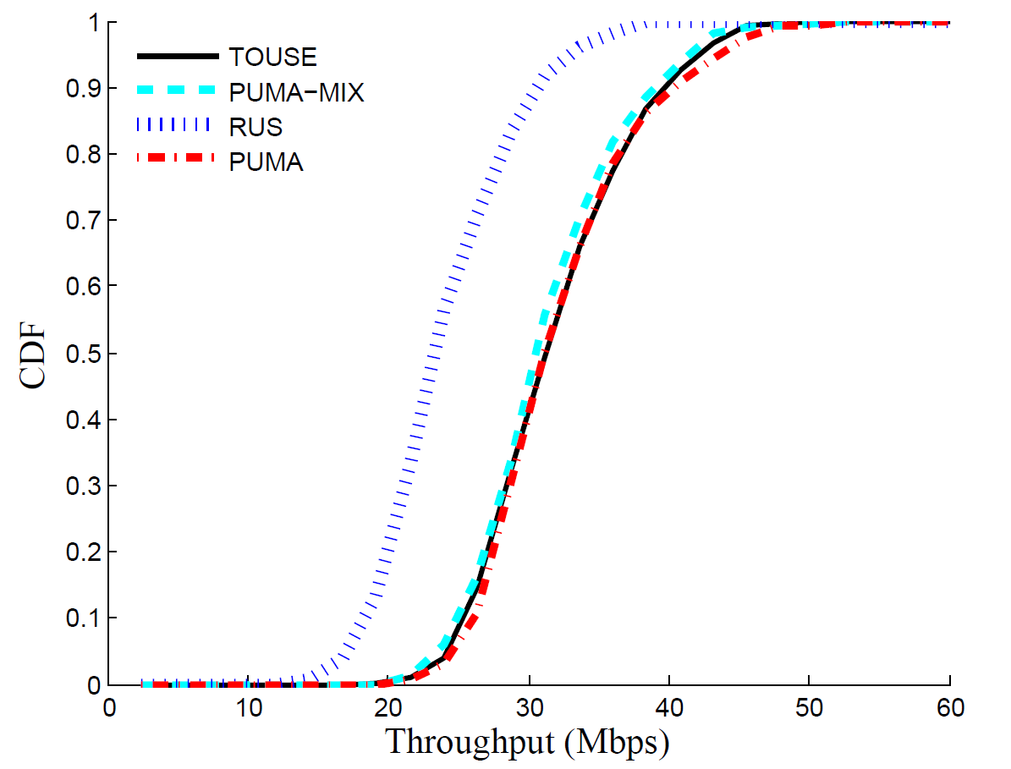

**Fig. 1**. Performance comparison by total throughput

5.1 Performance Comparison for Continuous Traffic

We evaluate the performance by comparing with other user selection schemes in terms of throughput gain. We set up an AP with 3 antennas and deploy 10 single-antenna users with randomly assignments of locations. Each of ten users have a different channel quality, and always have packets to receive. Before the transmission, AP obtains the queue information which is totally transmit data to each candidate users. Then AP estimates the bit-rate of each concurrent packet based on the effective SNR which is calculated by each user.

**Fig. 1** plots the CDF of the total throughput in 3 antennas scenarios, and shows the performance compared with other user selection schemes. The result shows that the traditional scheme, RUS, selecting users with an equal probability, without considering the channel characteristics and other criterions. Compared to RUS, the average throughput gain from enabling concurrent transmissions with TOUSE's user selection is about in three antennas scenarios. This improvement mainly benefits from the following contributions: First, accurate rate prediction mechanism ensures the high packet reception rate, and reduces the time overhead without CSI feedback. Second, fully utilizing concurrent transmission time by overhead time matches based mechanism. The figure also shows that the PUMA-MIX and PUMA produce a throughput comparable to or even slightly higher than our user selection scheme. The performance of PUMA-MIX is similar to TOUSE's because of the same kind of scheduling algorithm. Although the PUMA performs slightly better than TOUSE and PUMA-MIX, it causes time overhead in the process of user selection than other two schemes. Besides, this time overhead is growing with the number of users.

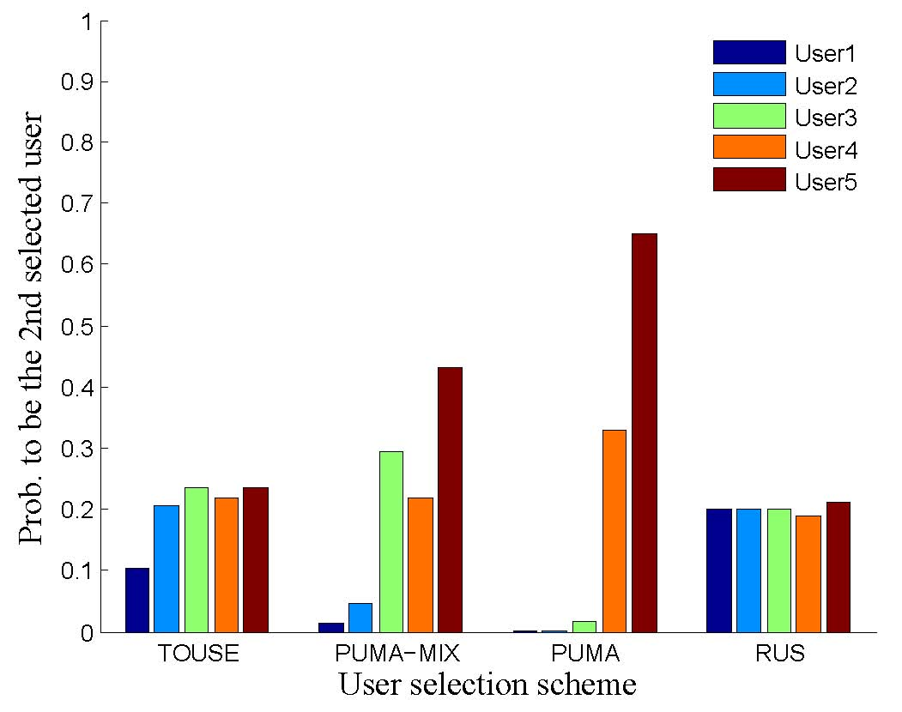

**Fig. 2**. Fairness comparison in a 3-antenna AP scenario

5.2 Throughput Fairness Analysis

In this section, we analysis the opportunities of user selection in a three antenna AP scenario, which is better to show the performance. In order to analysis the fairness of TOUSE, users should be put into difference scenarios and evaluate the influence. There are five specific regions, where have different channel quality and one user to communicate with AP. In the simulation, *user1*, *user4* are located in the region with worst and best channel quality, about and respectively. The quality of region *user2* is better than *user1*, but worse than *user3*, and *user5* is a control group with randomly case.

During the user selection process, the user group for downlink transmission was selected one after another. In the first round of simulation, TOUSE chooses a lucky user randomly, which means that TOUSE enables all clients to get almost an equal probability to be selected first. In order to show more convincing results, we plot in **Fig. 2**. The opportunities is to be second selected for each user in total selection process, which is the metric using for evaluating fairness. The figure shows that both the RUS scheme and our TOUSE enable all users to get almost an equal probability to be the second selected user. This implies that TOUSE enables users to achieve a similar level of fairness compared with fair contention mechanism. The probability of *user1* in TOUSE is slightly lower than other users. Because *user1* is located in a region with the worst channel quality, it results in the lowest throughput rate. In PUMA and PUMA-MIX, it gives little chance to low-throughput users. The user who has higher value of SNR gets more opportunities to be selected. Because these schemes selected concurrent transmit group just depend on throughput of each user.

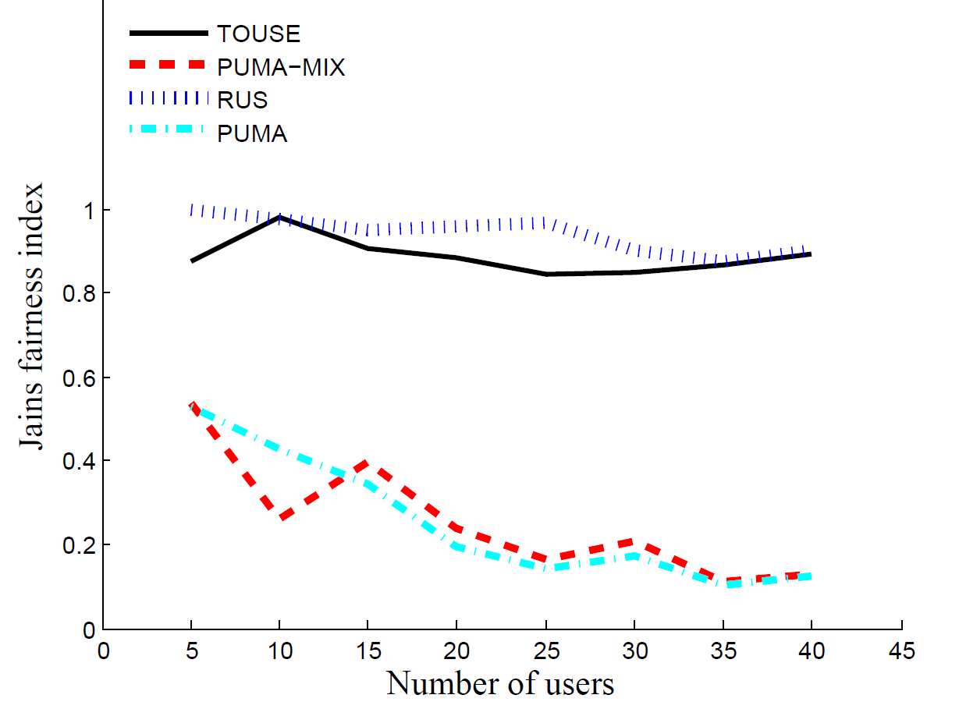

**Fig. 3**. Jain's fairness index versus the number of users for different user selection mechanism

In order to display the performance of TOUSE more clearly, we introduce one of the most relevant fairness indicators called Jain's fairness index (JFI) [35]. The definition as follows.

. (12)

Where presents the total number of users competing for channel, denotes channel access times of user at all time. ranges from (only one user is served) to 1 (all users are served at the same possibility). **Fig. 3** plots the Jain's fairness index for TOUSE, PUMA-MIX, PUMA and RUS as a function of the number of users in a 3-antenna AP scenario. It shows that the fairness performance of the proposed TOUSE clearly outperforms PUMA and almost close to the ideal case. From the curve in the figure, there are little chance for low channel quality users to compete channel with the increase in number of users. Trough and crest in the curve present that different candidate user group lead different optimal solution in each scheme. While the size of candidate user group is small, the sample distribution is uneven, which lead some trough or crest in the performance curve.

5.3 Effect of Number of Transmit Antennas

This subsection showing the performance influence by the number of transmit antennas on AP, and analysis by the throughput of network for each selection scheme. From 802.11ac standard, MU-MIMO transmissions are limited to four client. In the simulation, we only set that the number of transmitting antennas at the AP varies from 2 to 4, and 50 users which randomly distributed around AP competing for the channel. **Fig. 4** plots the performance of throughput. It shows that user selection is also important even for small scale MU-MIMO system, but it is more necessary for large scale system. Because the performance of RUS scheme getting weaker along the increased of transmit antennas. Compared with other user selection schemes, all have achieved a similar throughput gain, even if the number of antennas increased. Consider the problem of fairness lead TOUSE shows lower throughput in comparison with other selection scheme while the number transmit antennas equals 4. The one with low channel quality increase the inter-user interference, but PUMA only focus on the user with high delivery rate and performance better. The ceiling of throughput is reached with the antennas number growing, due to a large amount of interference between the inter-user. Besides, the result implies that increasing the number of parallel streams is not always the most efficient transmission scheme. Next we will prove that whether the TOUSE can perform scalability.

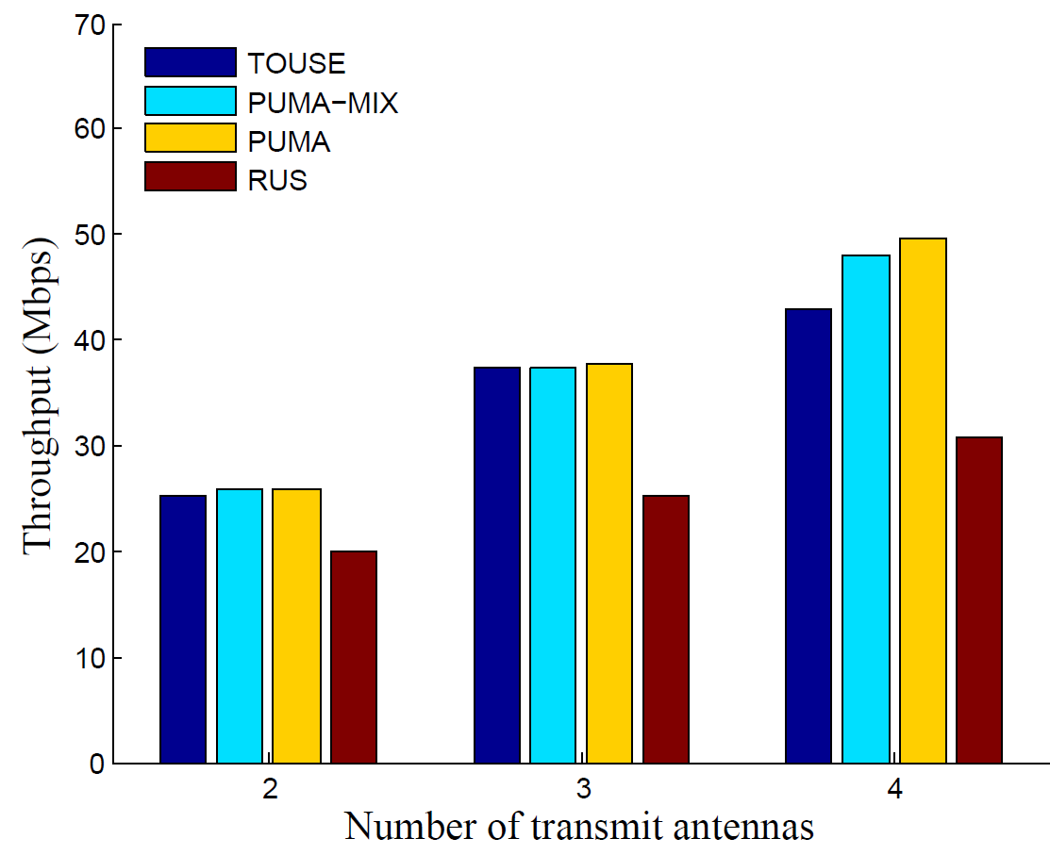

**Fig. 4**. Performance in different AP scenario

5.4 Impact of Number of Users

Here we evaluate the performance of TOUSE when the number of users varies from 5 to 50. We check the total network throughput gain increased by TOUSE when each user just has limited packet to receive. In each simulation, the AP transmits concurrent queue packets to its matching user, and thereby the throughput is calculated based on the process of transmission.

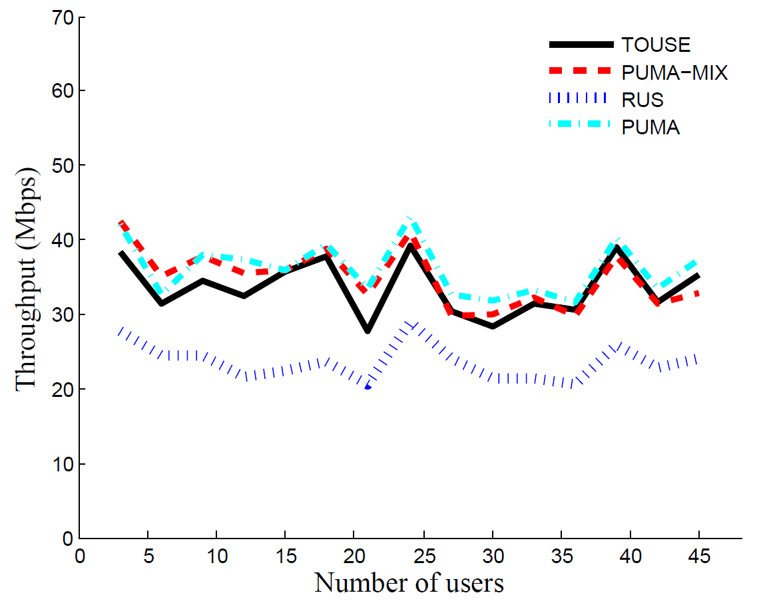

**Fig. 5**. Performance impact by number of users

We plot the **Fig. 5** to represent the performance of scalable. The effect of increasing the number of user on TOUSE, PUMA and PUMA-MIX is relatively small, implying that the TOUSE is performing well even when the network scales up. Since the RUS does not consider the channel characteristics and packet queueing status of users, its total network throughput is poor. However its performance is also independent of the number of users. During this simulation, PUMA get higher throughput whatever the network scales up due to the exhaustively research compared with other schemes. But the total throughput of PUMA-MIX is similar to TOUSE, which means that our user selection has similar level of throughput with a throughput first contention mechanism. From the curve in the figure, it shows the performance of PUMA is better than TOUSE in most time, sometimes it performance different due to the size of sample.

5.5 Performance in Different Channel Quality Regions

In order to evaluate the performance of TOUSE while the network channel quality is different. Here give several simulations which have different channel qualities respectively. In a low SNR region, the value of SNR just varies from 0 to 5dB, and varies from 15 to 20dB in a highest region. We set 10 users located in a region with similar channel quality. **Fig. 6** reveals that user selection mechanism is not so significant for MU-MIMO in a low SNR region, because the interference is large enough to each user no matter what the combination of beamforming group is. However, with higher link qualities, these user selection schemes which is considered the channel characteristics of users performs obviously better than RUS. Figure also shows that the TOUSE brings out a throughput improvement over RUS even in a low SNR region. Compared with PUMA and PUMA-MIX, TOUSE performs in the same level or slightly poor in mostly scenario. But TOUSE achieves a similar throughput gain with the increased of the channel quality. Obviously, TOUSE can perform better in different channel quality regions.

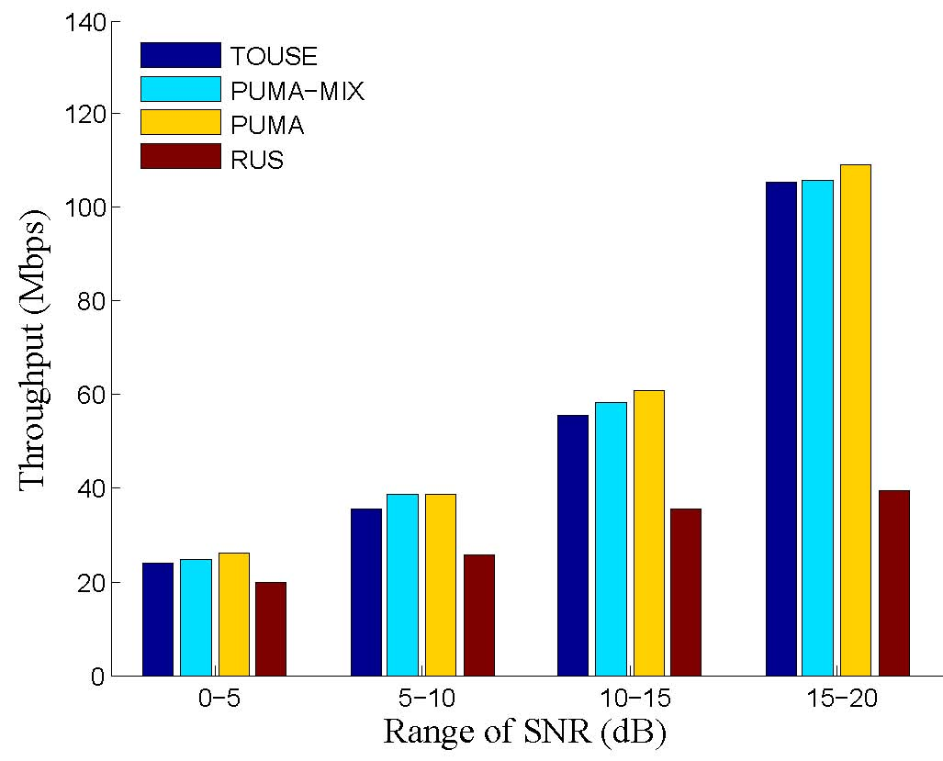

**Fig. 6**. Performance in different channel quality region

6. Conclusion

In this paper, we have presented TOUSE, a scalable and fairness user selection scheme for downlink MU-MIMO. TOUSE is a proportional fair schedular usually considers both network throughput and fairness. In order to reduce time overhead, we adopt a novel per-user data-rate estimation method without any CSI feedback. TOUSE selects optimal beamforming group by dynamic time warping based on mechanism, which makes full use of concurrent transmitting time and achieves equal opportunity of channel contention. We have simulated TOUSE along with three other user selection schemes. Simulation shows that TOUSE achieves a throughput gain over traditional scheme in three antennas AP scenarios, and the similar level of fairness compared with fair contention mechanism. We also proved that TOUSE can always achieve similar performance of throughput compared with throughput contention schemes. More details of QoS will be considered in our future work, and hope our research will be a significant step in future study.

References

1. Choi, Lai-U and Murch, Ross D, “A transmit preprocessing technique for multiuser MIMO systems using a decomposition approach,” *IEEE Transactions on Wireless Communications*, vol. 3, no. 1, pp. 20-24, 2004.
2. Gross, James, “Scheduling with outdated CSI: effective service capacities of optimistic vs. pessimistic policies,” in *Proc. IEEE International Workshop on Quality of Service (IWQoS)*, 2012.
3. T. Yoo and A. Goldsmith, “On the optimality of multiantenna broadcast scheduling using zero-forcing beamforming,” IEEE Journal on Selected Areas in Communications, vol. 24, no. 3, pp. 528–541, 2006.
4. Wang J, Love D J, Zoltowski M D. User selection with zero-forcing beamforming achieves the asymptotically optimal sum rate. IEEE Transactions on Signal Processing, 2008, 56(8): 3713-3726.
5. Xie Xiufeng, Zhang Xinyu, “Scalable user selection for MU-MIMO networks,” in *Proc. IEEE International Conference on Computer Communications (INFOCOM)*, pp. 808-816, 2014.
6. Xie Xiufeng, Zhang Xinyu and Sundaresan Karthikeyan, “Adaptive feedback compression for MIMO networks,” in *Proc. ACM International Conference on Mobile Computing and Networking (MobiCom)*, pp. 477-488, 2013.
7. Anand Narendra, Lee Jeongkeun, Lee Sung-Ju and Knightly Edward W, “Mode and User Selection for Multi-User MIMO WLANs without CSI,” in *Proc. IEEE International Conference on Computer Communications (INFOCOM)*, pp. 451-459, 2015.
8. Ma X, Gao Q, Marojevic V, et al. Hypergraph matching for MU-MIMO user grouping in wireless LANs. Ad Hoc Networks, 2016, 48: 29-37.
9. D. Halperin, W. Hu, A. Sheth, D. Wetherall, “Predictable 802.11 packet delivery from wireless channel measurements,” *ACM SIGCOMM Computer Communication Review,* vol. 41, no. 4, pp. 159-170, 2011.
10. Gong M X, Hart B, Mao S, “Advanced wireless lan technologies: IEEE 802.11 ac and beyond,” *ACM GetMobile: Mobile Computing and Communications,* vol. 18, no. 4, pp. 48-52, 2015.
11. S. Deng, R. Netravali, A. Sivaraman, H. Balakrishnan, “WiFi, LTE, or Both?: measuring multi-homed wireless internet performance,” in *Proc. ACM Internet Measurement Conference (IMC)*, pp.181-194, 2014.
12. R. Liao, B. Bellalta, M. Oliver, Z. Niu, “MU-MIMO mac protocols for wireless local area networks: A survey,” *IEEE Communications Surveys and Tutorials,* vol. 18, no. 1, pp. 162-183, 2014.
13. Lee Donghun, “Performance analysis of ZF-precoded scheduling system for MU-MIMO with generalized selection criterion,” *IEEE Transactions on Wireless Communications,* vol. 12, no. 4, pp. 1812-1818, 2013.
14. E. Aryafar, N. Anand, T. Salonidis, E. W. Knightly, “Design and experimental evaluation of multi-user beamforming in wireless LANs,” in *Proc. ACM International Conference on Mobile Computing and Networking (MobiCom)*, pp.197-208, 2010.
15. W. Lim, G. Kim, J. Kim, H. Park, K. Lee, H. Jang, “Performance of linear precoding and user selection in IEEE 802.11 ac downlink MU-MIMO system,” in *Proc. IEEE Wireless Communications and Networking Conference (WCNC),* pp. 925-929, 2014.
16. Miller Rob and Trappe Wade, “On the vulnerabilities of CSI in MIMO wireless communication systems,” *IEEE Transactions on Mobile Computing,* vol. 11, no. 8, pp. 1386-1398, 2012.
17. A. Zhou, T. Wei, X. Zhang, M. Liu, Z. Li, “Signpost: Scalable MU-MIMO Signaling with Zero CSI Feedback,” in *Proc. ACM International Symposium on Mobile Ad Hoc Networking and Computing (MobiHoc),* pp. 327-336, 2015.
18. Maruko T, Yamaguchi T, Yoshimura T, et al. Efficient combination of multi-user MIMO THP and user selection based on spatial orthogonality. Wireless Communications and Networking Conference (WCNC), 2016 IEEE. IEEE, 2016: 1-5.
19. T. –W. Kuo, K. –C. Lee, K. C. -j Lin, M.-J. Tsai, “Leader-Contention-Based User Matching for 802.11 Multiuser MIMO Networks,” *IEEE Transactions on Wireless Communications,* vol. 13, no. 8, pp. 4389-4400, 2014.
20. S. Huang, H. Yin, J. Wu, V. Leung, “User selection for multiuser MIMO downlink with zero-forcing beamforming,” *IEEE Transactions on Vehicular Technology,* vol. 62, no. 7, pp. 3084-3097, 2013.
21. W. –L. Shen, K. C. Lin, M. –S. Chen, K. Tan, “SIEVE: Scalable user grouping for large MU-MIMO systems,” in *Proc. IEEE International Conference on Computer Communications (INFOCOM),* pp. 1975-1983, 2015.
22. K. Ko, J. Lee, “Multiuser MIMO user selection based on chordal distance,” *IEEE Transactions on Communications,* vol. 60, no. 3, pp. 649-654, 2012.
23. X. Zhang, K. Sundaresan, M. A. A. Khojastepour, S. Rangarajan, K. G. Shin, “NEMOx: scalable network MIMO for wireless networks,” in *Proc. ACM International Conference on Mobile Computing and Networking (MobiCom),* pp. 453-464, 2013.
24. W.-L. Shen, K. C.-J. Lin, S. Gollakota, M.-S. Chen, “Rate adaptation for 802.11 multiuser MIMO networks,” *IEEE Transactions on Mobile Computing,* vol. 13, no. 1, pp. 35-47, 2014.
25. Oscar Bejarano, Roger Pierre Fabris Hoefel and Edward W. Knightly, “Resilient multi-user beamforming WLANs: Mobility, interference, and imperfect CSI,” in *Proc. IEEE International Conference on Computer Communications (INFOCOM),* 2016.
26. Shepard C, Javed A, Zhong L, “Control Channel Design for Many-Antenna MU-MIMO,” in *Proc. ACM International Conference on Mobile Computing and Networking (MobiCom),* pp. 578-591, 2015.
27. Sur S, Pefkianakis I, Zhang X, et al, “Practical MU-MIMO user selection on 802.11 ac commodity networks,” in *Proc. ACM International Conference on Mobile Computing and Networking (MobiCom),* pp. 122-134,2016.
28. M. Esslaoui, F. Riera-Palou, G. Femenias, “A fair MU-MIMO scheme for IEEE 802.11 ac,” in *Proc. IEEE International Symposium on Wireless Communication Systems (ISWCS),* pp. 1049-1053, 2012.
29. N. Ravindran, N. Jindal, “Multi-user diversity vs. accurate channel state information in MIMO downlink channels,” *IEEE Transactions on Wireless Communications,* vol. 11, no. 9, pp. 3037-3046, 2013.
30. Tan K, Liu H, Fang J, et al. “SAM: enabling practical spatial multiple access in wireless LAN,” in *Proc. ACM international conference on Mobile computing and networking*, 2009: 49-60.
31. H. Yang, T. L. Marzetta, “Performance of conjugate and zero-forcing beamforming in large-scale antenna systems,” *IEEE Journal on Selected Areas in Communications,* vol. 31, no. 2, pp. 172-179, 2013.
32. Jindal Nakul, “MIMO broadcast channels with finite-rate feedback,” *IEEE Transactions on Information Theory,* vol. 52, no. 11, pp. 5045-5060, 2006.
33. Perahia E, Stacey R. “Next generation wireless LANs: 802.11 n and 802.11 ac.” *Cambridge university press*, 2013.
34. M. Muller, “Dynamic time warping,” in *Proc*. *Springer Information retrieval for music and motion,* 2007.
35. R. Jain, D. –M. Chiu, W. R. Hawe, “A quantitative measure of fairness and discrimination for resource allocation in shared computer system,” *Eastern Research Laboratory, Digital Equipment Corporation Hudson, MA*, vol. 38, 1984.